PROTON PUMP INHIBITORS FOR PREVENTING UPPER GI BLEEDING IN PATIENTS ON DUAL ANTIPLATELET THERAPY: A SYSTEMATIC REVIEW AND META-ANALYSIS

ABSTRACT

BACKGROUND
Dual antiplatelet therapy (DAPT) is essential for secondary prevention in cardiovascular disease but increases the risk of upper gastrointestinal (GI) bleeding. Proton pump inhibitors (PPIs) are commonly used as a prophylactic measure to mitigate this risk. However, concerns about their potential cardiovascular side effects persist. This systematic review and meta-analysis evaluate the efficacy and safety of PPIs in preventing upper GI bleeding in patients on DAPT.
METHODS
A comprehensive literature search was conducted across PubMed, Embase, Cochrane Library, and Google Scholar to identify RCTs published up to December 2024 that evaluated randomized controlled trials comparing PPI use with control in patients on DAPT. The primary outcome was the risk of upper GI bleeding. Secondary outcomes included myocardial infarction (MI), cardiovascular cause of mortality, and all-cause mortality. Data were analyzed using a random-effects model, and risk ratios (RR) with 95% confidence intervals (CI) were reported.
RESULTS
Our meta-analysis included eight RCTs with a total of 6768 patients (3385 in PPI group and 3383 in control group). Our meta analysis demonstrated that PPIs significantly reduced the risk of upper gastrointestinal (GI) bleeding compared to controls (RR 0.38; 95% CI: 0.25–0.58; p < 0.00001) with minimal heterogeneity (I² = 0%). There was no significant difference in the risk of myocardial infarction (RR 0.84; 95% CI: 0.11–6.58; p = 0.87; I² = 40%) or cardiovascular cause of mortality (RR 0.92; 95% CI: 0.75–1.14; p = 0.45; I² = 0%) between the PPI and control groups. Notably, PPI use was associated with a significant reduction in all-cause mortality (RR 0.46; 95% CI: 0.27–0.80; p = 0.005; I² = 0%). These findings highlight the efficacy and safety of PPIs in preventing upper GI bleeding and their potential survival benefit without increasing cardiovascular risks.
CONCLUSION
PPIs are effective in reducing the risk of upper GI bleeding in patients on DAPT without increasing the risk of myocardial infarction or cardiovascular mortality. Moreover, PPI use may provide a survival benefit by reducing all-cause mortality. These findings support the use of PPIs as a safe and effective strategy to prevent upper GI bleeding in this high-risk population. Further studies are warranted to explore the potential mechanisms underlying the observed reduction in mortality.

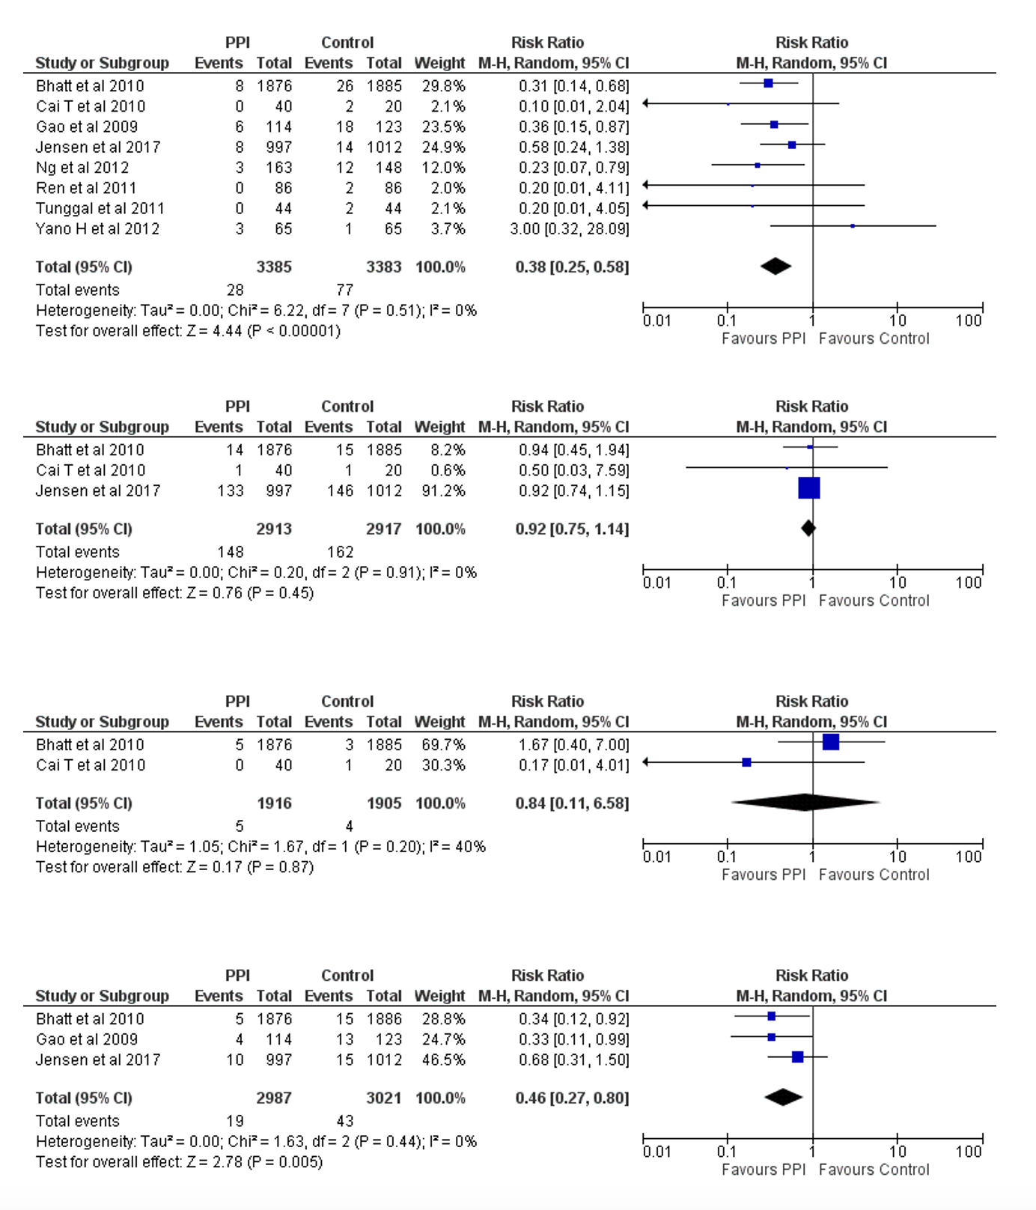

Fig 1. Forest Plots of Upper Gastrointestinal Bleeding between PPI, Control, Myocardial Infarction, Cardiovascular Cause of Mortality & All-Cause Mortality

