Prospective Evaluation of Biomarker Risk Stratification using Capsule Sponge in the Surveillance of Barrett’s Oesophagus: Results from UK Real-world Implementation Pilots
Introduction
Endoscopic surveillance is the standard of care for Barrett’s oesophagus (BO), but its effectiveness is inconsistent and operator-dependent. Pan-oesophageal cell collection devices with biomarkers provide patients with a less operator-dependent, cost-effective alternative. We previously developed a risk stratification score for capsule-sponge surveillance.¹ Here, we prospectively evaluated this risk stratification tool in patients undergoing capsule-sponge triage to determine the timing of follow-up endoscopy. The aim of the study is to is to prospectively evaluate the accuracy of the risk stratification tool in patients undergoing capsule-sponge triage for BO surveillance.
Methods
Patients were recruited from ten hospitals (DELTA study ISRCTN91655550, 2020-2022, and NHS England implementation study 2022–2024). We included patients with a history of BO who had capsule sponge and endoscopy follow-up with biopsies. All capsule sponge samples were processed centrally in an accredited laboratory (Cyted Medical), with positive biomarker results (p53, atypia) independently reviewed by two pathologists. Patients were assigned into one of three risk groups: low (clinical and sponge biomarkers negative), moderate (positive clinical biomarkers - age, sex and segment length), and high risk (positive sponge biomarkers- p53, atypia and atypia of uncertain significance (AUS)) (Table 1, legend). Endoscopic follow-up intervals were guided by the risk result at a time interval directed by the clinician. The overall prevalence of dysplasia in the cohort and the prevalence of dysplasia for each risk category were calculated.
Results
796 patients were included of which 415 (52.1%) were low, 253 (31.8%) moderate, and 128 (16.1%) were high-risk (Table 1). Among the low-risk category, the prevalence of HGD, and any dysplasia was 0.7% (3/415), and 2.9% (12/415), respectively. No intramucosal or invasive OAC (≥T2) were detected in the low- or moderate-risk groups. The high-risk group was 4-fold enriched for any dysplasia: 38.3% (49/128) compared with the overall dysplasia detection rate of 9.8% (78/796). When both p53 and atypia were positive, 80.8% (21/26) had dysplasia, compared to single biomarker positivity of 44.4% (4/9) for p53 alone, and 66.7% (2/3) when atypia alone was positive. Among those with AUS, often linked to inflammation, 17.9% (4/67) had dysplasia.
Conclusion
This large prospective study has shown that this risk stratification panel can accurately risk stratify patients undergoing BO surveillance with the low-risk group having <1% risk of HGD with no cases of missed OAC. This suggests that sponge-only surveillance is safe in low-risk patients, while positive high-risk biomarkers can successfully enrich for dysplasia and help direct resources towards patients at higher risk.
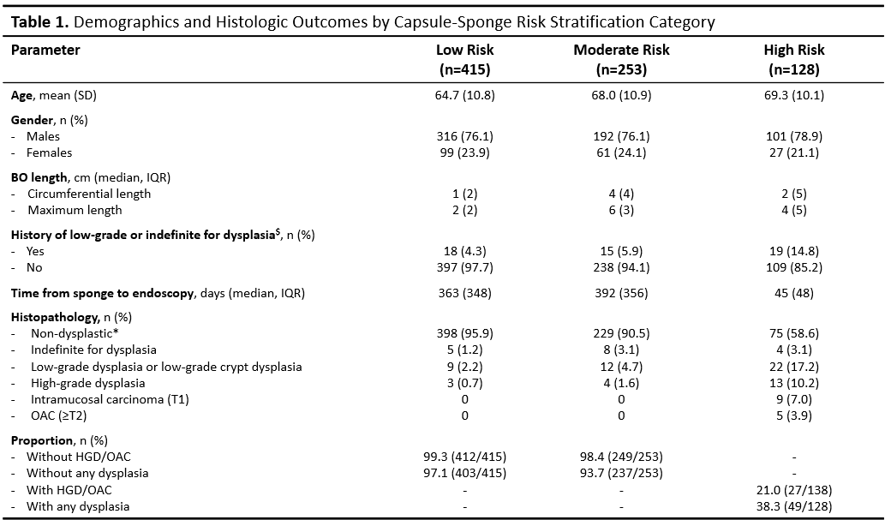
SD, standard deviation; IQR, interquartile range; NPV, negative predictive value; PPV, positive predictive value; NDBE, non-dysplastic BO; OAC, oesophageal adenocarcinoma (≥T2)
$History of dysplasia is defined as the presence of indefinite for dysplasia or low-grade dysplasia detected during the endoscopy performed second-to-last, but not observed in the most recent endoscopy
*Includes intestinal metaplasia of the gastro-oesophageal junction and gastric metaplasia and considered by clinicians as having BO
High risk: positive for p53 immunohistochemistry or presence of atypia (amounting to dysplasia or uncertain significance) on sponge microscopy.
Moderate risk: presence of clinical risk factors: 1) M>10 or C>6; 2) M>5 or C≥3 and Male; or 3) M>5 and C≥3 and age >60
Low risk: negative sponge biomarkers and no clinical risk factors.

Reference
1. Pilonis ND, Killcoyne S, Tan WK, et al. Use of a Cytosponge biomarker panel to prioritise endoscopic Barrett's oesophagus surveillance: a cross-sectional study followed by a real-world prospective pilot. The Lancet Oncology 2022.

