Introduction:
The proteome constitutes a significant source of therapeutic targets. We conducted a proteome-wide Mendelian randomization (MR) investigation aiming to delineate candidate protein markers and therapeutic targets for esophageal cancer (EC).
Methods:
Protein quantitative trait loci (pQTLs) were derived from a published genome-wide association studies (GWASs) on plasma proteome, yielding summary-level data for 4719 circulating protein markers. Genetic associations with EC were extracted from the FinnGen cohort (619 cases and 314,193 controls). Subsequent colocalization and summary-data-based MR (SMR) analyses were conducted to substantiate the causal involvement of candidate proteins. Additionally, single cell-type expression analysis, protein-protein interaction (PPI) analysis and druggability evaluation were performed to identify specific cell types exhibiting enriched expression and to prioritize potential therapeutic targets.
Results:
In aggregate, genetically predicted levels of 133 proteins were linked to EC risk. Elevated levels of 60 proteins and decreased levels of 73 proteins were associated with heightened EC risk, with ACE, VEGF sR2, THSD, EphB4, MET, and JAG1 emerging as prioritized candidates based on robust evidence. These protein-coding genes predominantly express in endothelial cells, epithelial cells, macrophages, and B cells in esophageal tumor tissue. Among these proteins, EphB4, Met, and VEGF sR2 were identified to participate in transmembrane receptor protein tyrosine kinase activity pathways. Moreover, five proteins, ACE, EphB4, KDR, JAG1, and MET, previously targeted for drug development in autoimmune diseases and other cancers, exhibited potential for repurposing as therapeutic targets for EC.
Conclusions:
This investigation delineated several protein biomarkers associated with EC risk, offering novel insights into its etiology and promising avenues for the development of screening biomarkers and therapeutic agents for EC.

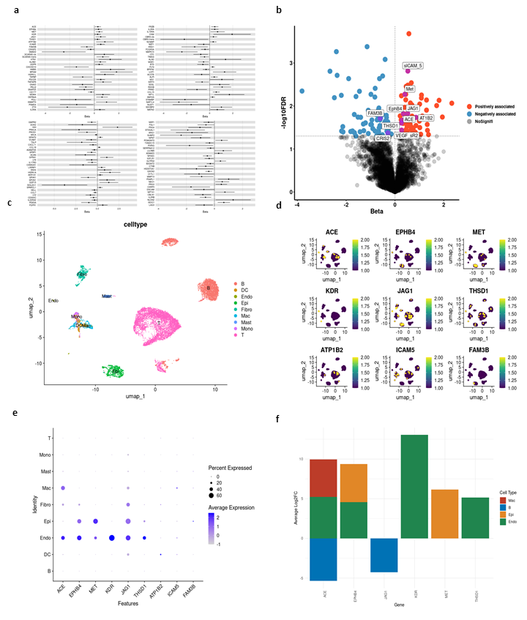
Fig 1a. The forest plot shows the effect values ​​of each protein on the risk of esophageal cancer after Mendelian randomization analysis.
b. The volcano plot shows the results of proteome-wide Mendelian randomization, with the horizontal axis representing the effect value Beta and the vertical axis representing the significance, expressed as -log10FDR. The protein names that share genetic factors with esophageal cancer in the coloc analysis are also marked.
c. Nine cell types in esophageal cancer were identified by single-cell transcriptomics and depicted in a scatter plot
d. Scatter plot showing the expression of target protein-coding genes in each cell type
e. Bubble plots showing the expression of target protein-coding genes in each cell type
f. The bar graph shows the enrichment of six protein-coding genes in a certain cell type at the average Log2FC > 0.5 and FDR < 0.05 level. The vertical axis is the log2FC value.

