Topic:
Nurse-led clinic (NLC) to expedite pathway for ophthalmology screening of IBD patients prior to treatment with Sphingosine-1-phosphate receptor (S1PR) modulators.

Authors:
Anum Javed¹, Anita D’Souza¹, Saad Younis¹, James Alexander¹, Lucy Hicks¹

Affiliations:
1 Imperial College London, Imperial College Healthcare NHS Trust

Introduction:
S1PR modulators, a new class of small molecules, have shown promising results in the treatment paradigm of moderate to severe ulcerative colitis (UC). The two approved drugs, etrasimod and ozanimod, have been associated with an increased risk of macular oedema. In approved labelling for S1PR modulators, an ophthalmic evaluation is recommended prior to commencing treatment in all patients. We established a NLC to facilitate prompt ophthalmology screening at a tertiary IBD centre.

Methods:
We screened our IBD database to identify patients suitable for S1PR modulators. In our NLC, all patients received prior counselling and suitability confirmed depending on patient’s characteristics and clinical status. Following comprehensive evaluation including routine pre-biologic screening, patients were referred to ophthalmology one-stop clinic on a special pathway with target to be reviewed within 8 weeks.

Results:
In our IBD clinics, we identified 7 potential eligible patients for treatment with S1PR modulators between July 2024 – December 2024. However, 3 of these patients were eliminated from data (2 declined to initiate therapy, 1 developed acute severe UC). The remaining 4 patients were promptly referred to the Ophthalmology clinic and completed comprehensive assessment. The examination included optical coherence tomography (OCT) followed by review by Consultant Ophthalmologist as a one-stop clinic. The results were reviewed by the specialist IBD nurses who discussed the findings with the patients and arranged further follow-up if required. The treating clinician was informed of the results and patients’ GP notified. This process facilitated the establishment of a structured protocol, leading to a measurable reduction in the time required to undergo the necessary ophthalmological examinations, which would otherwise fall under the domain of primary care.

Conclusions:
As prescribing of advance therapies including small molecules is expected to increase, demand for treatment counselling and monitoring will follow. This direct access pathway is an effective use of resources to provide a timely and valuable service, as well as reducing consultant time. To the best of our knowledge, this represents the first nurse-led initiative in the country aimed at enabling ophthalmological screening for IBD patients starting S1PR modulators.

Figure 1:
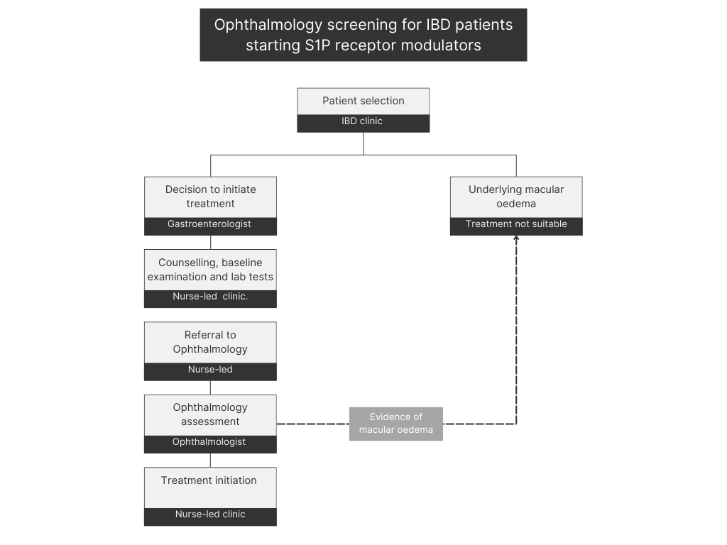

- Sandborn WJ, Vermeire S, Peyrin-Biroulet L, et al. Etrasimod as induction and maintenance therapy for ulcerative colitis (ELEVATE): two randomised, double-blind, placebo-controlled, phase 3 studies. Lancet. 2023, 401(10383):1159-71. https://doi.org/10.1016/s0140-6736(23)00061-2

