COMPARATIVE EFFICACY AND SAFETY OF TENOFOVIR ALAFENAMIDE VS. TENOFOVIR DISOPROXIL FUMARATE IN CHRONIC HEPATITIS B: META-ANALYSIS OF RANDOMISED CONTROLLED TRIALS
ABSTRACT
Background:
Chronic Hepatitis B (CHB) is a global health concern, with significant risks of liver-related complications and mortality. Antiviral treatments such as Tenofovir Disoproxil Fumarate (TDF) and Tenofovir Alafenamide (TAF) are commonly used for HBV suppression. TAF is a newer formulation designed to offer similar efficacy to TDF while improving safety profiles, especially in terms of bone and renal health. This meta-analysis aimed to compare the efficacy and safety of TAF and TDF in treating CHB.
Methods:
A systematic literature search was conducted in August 2023, focusing on randomised controlled trials (RCTs) comparing TAF and TDF for the treatment of CHB. Four RCTs involving 1,960 patients were included. The primary outcome was the proportion of patients achieving HBV DNA suppression to levels <15-29 IU/ml. Secondary outcomes included ALT normalisation, changes in bone mineral density (BMD), serum creatinine levels, estimated glomerular filtration rate (eGFR), and LDL cholesterol levels. Pooled data were analysed using relative risk (RR) and mean difference (MD) with 95% confidence intervals (CIs).
Results:
- Primary Outcome: Both TAF and TDF demonstrated similar efficacy in achieving virological suppression, with no significant difference in HBV DNA reduction (RR=1.00; 95% CI 0.96 to 1.05; p=0.82).
- Secondary Outcomes:
  - ALT Normalisation: TAF was more effective in achieving ALT normalisation (RR=1.38; 95% CI 1.16 to 1.64; p=0.0002).
  - Bone Mineral Density (BMD): TAF showed significantly less reduction in hip (MD=1.44; 95% CI 0.98 to 1.91; p<0.00001) and spine BMD (MD=1.93; 95% CI 1.42 to 2.44; p<0.00001).
  - Kidney Function: TAF caused less elevation in serum creatinine (MD=-0.02; 95% CI -0.03 to -0.01; p<0.00001) and less decline in eGFR (MD=3.55; 95% CI 2.97 to 4.14; p<0.0001).
  - LDL Cholesterol: TAF was associated with higher LDL cholesterol levels compared to TDF (RR=4.95; 95% CI 1.21 to 20.29; p=0.03).
Conclusion:
TAF demonstrated comparable efficacy to TDF in HBV DNA suppression but showed superior outcomes in terms of ALT normalisation, bone mineral density preservation, and kidney function. However, TAF led to higher LDL cholesterol levels, which may require monitoring. These findings suggest that TAF could be a safer alternative to TDF for CHB patients, particularly in those at risk for bone and renal complications. Further long-term studies are needed to confirm these results, particularly in special populations.
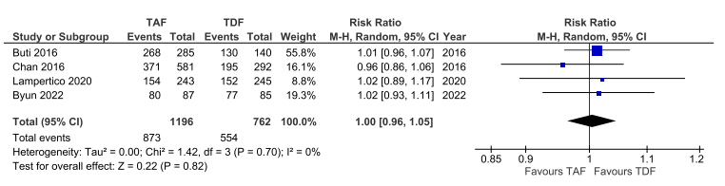
Fig 1. Effect of TAF compared to TDF on virological suppression

