DIAGNOSTIC ACCURACY OF BOWEL ULTRASONOGRAPHY IN MONITORING INFLAMMATORY BOWEL DISEASE: AN UPDATED SYSTEMATIC REVIEW AND META-ANALYSIS

ABSTRACT

BACKGROUND
Inflammatory bowel disease (IBD), including Crohn’s disease (CD) and ulcerative colitis (UC), is characterised by chronic gastrointestinal inflammation, which significantly impacts patients' quality of life. Effective monitoring is crucial for symptom control and maintaining remission. However, current diagnostic methods such as colonoscopy, symptom diaries, and inflammatory markers like faecal calprotectin and C-reactive protein (CRP) have specificity, invasiveness, and practicality limitations.

METHODS
This study updates a previous systematic review and meta-analysis, evaluating the diagnostic utility of bowel ultrasonography (BUS) in adults with IBD. The analysis followed PRISMA-DTA guidelines, including 37 studies that assessed BUS diagnostic accuracy against colonoscopy as the reference standard. Subgroup analyses examined different BUS modalities, such as small intestine contrast ultrasonography (SICUS) and BUS with Color Doppler.

RESULTS
The pooled sensitivity and specificity for BUS in IBD were 90.0% (85.5%-93.2%) and 83.5% (76.8%-88.6%), respectively, with a diagnostic odds ratio of 45.8 (27.6-76.0). SICUS demonstrated the highest sensitivity (95%), while BUS with Color Doppler exhibited the highest specificity (85.1%). BUS showed strong diagnostic performance across IBD subtypes, with the highest sensitivity observed in postsurgical CD recurrence (91.9%) and the highest specificity in CD (86.1%). Meta-regression identified side-to-side anastomosis as significantly correlated with diagnostic outcomes in postoperative CD.

CONCLUSION

This updated meta-analysis confirms that BUS is a highly accurate, non-invasive tool for monitoring IBD, providing real-time insights into disease activity and anatomical changes. Its diagnostic performance varies by modality and target condition, with SICUS and BUS with Colour Doppler showing particular strengths. These findings support the integration of BUS into routine IBD management as a practical alternative to more invasive diagnostic methods.

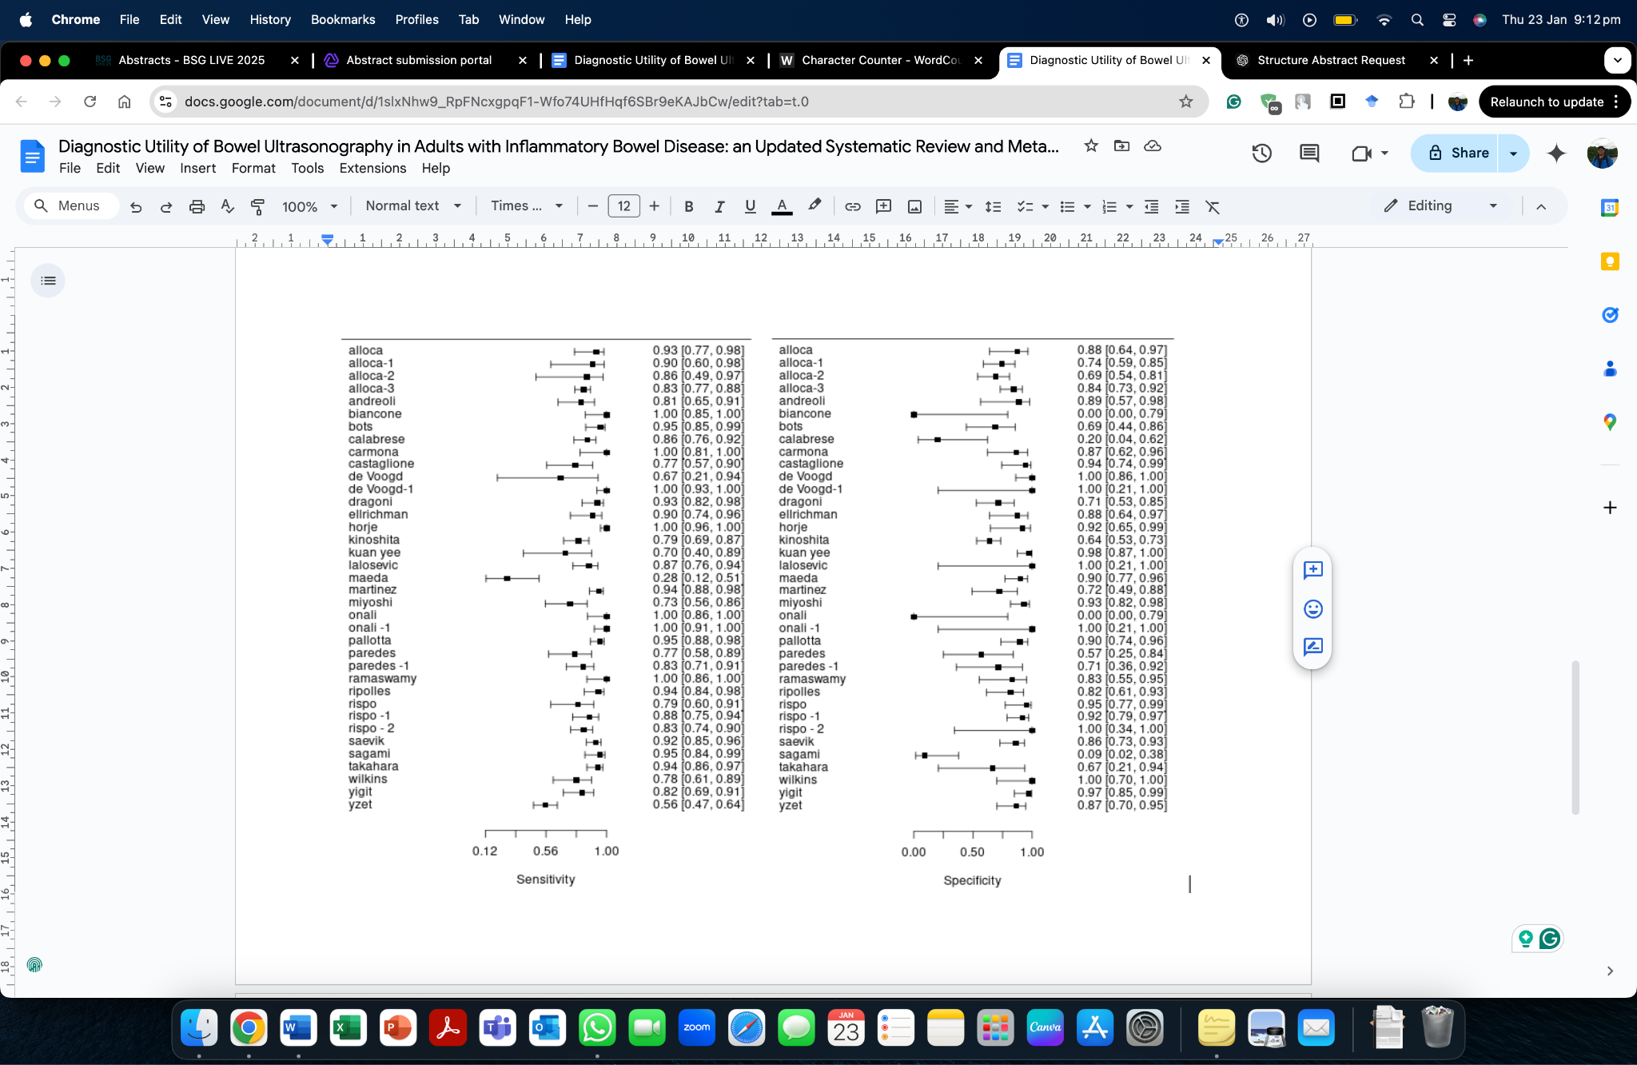
Fig 1. Forest Plots of Sensitivity & Specificity

