Introduction:
Intestinal stem cells (ISCs) continuously divide and differentiate into multiple lineages of enterocytes, a process that places high energy demands. Recent evidence implicates bioenergetic failure of ISCs with non-resolving inflammation in Ulcerative Colitis (UC).
Methods:
In treatment-naïve UC patients, we characterized mitochondrial oxidative phosphorylation (OXPHOS) and metabolic proteins in epithelial and ISCs, performed single-cell RNA sequencing (scRNA-seq) to identify deregulated metabolic pathways, and assessed their biological relevance on intestinal regeneration with in-depth ex vivo metabolic platforms, including SCENITH*.
Results:
Single-cell quantitative immunofluorescence showed loss of mitochondrial OXPHOS Complex I and IV in UC (n=10/group; p<0.0001) and UC-derived organoids (n=20/group; p<0.0001), suggesting bioenergetic failure transmitted from ISCs to daughter epithelial cells. scRNA-seq of ISCs from active UC revealed significant ketogenesis pathway downregulation, with HMGCS2 as the top downregulated gene (FC-2.76, p<0.0001). HMGCS2, the rate-limiting mitochondrial matrix ketogenesis enzyme, produces the ketone body βHB which, alongside providing metabolites for the TCA cycle, has important roles in stem cell fate-signalling. HGMCS2 expression was reduced along the crypt axis in active UC (n=20/group; p<0.001). Moreover, we find via colorimetric assay that colonic organoids produce and secrete βHB, and this is reduced in active UC (n= 5/group, p <0.001). βHB supplementation of UC organoids restores ISC function, measured via growth assay (n=5/group, p<0.05)(Figure 1). Further scRNA-seq of βHB treated UC organoids revealed that βHB aids mitochondrial function and reduces cellular stress in ISCs, lowering expression of genes associated with stress and protein misfolding ( VDAC3 and HSPD1), while increasing mitophagy (PINK1). Functionally, we confirm this by showing βHB restored OXPHOS capacity in UC organoids using SCENITH (n=3/group, p<0.05). βHB also reduced cellular and mitochondrial reactive oxygen species, measured via Cellrox (n=9/group, p<0.01). In UC organoids, fenofibrate (PPARα agonist), induced HMGCS2 expression (p<0.001) and βHB production (p<0.05). Finally, HMGCS2 protein expression significantly increased in responders to therapy with mucosal healing (n=4 paired samples, p<0.05) (Figure 1).
Conclusions:
We provide the first combined evidence of mitochondrial dysfunction and ketogenesis failure (‘primary’ and ‘backup’ energy failure) in UC. Crucially, restoring ketogenesis reverses the ISC pathogenic defect thus, opening a new ‘immuno-metabolic’ therapeutic approach in UC.
* Single Cell Energetic Metabolism by Profiling Translation Inhibition

Figure 1. βHB restores UC ISC function
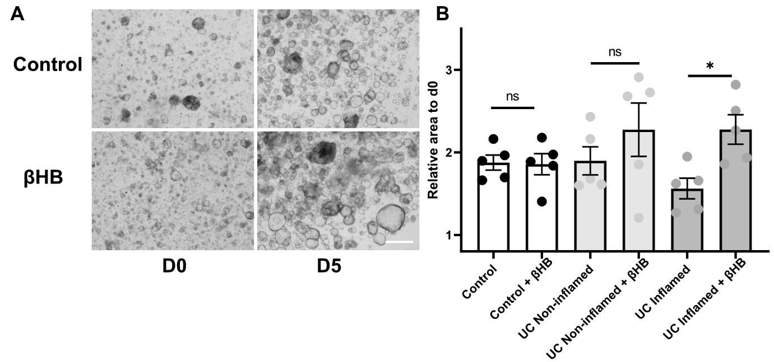

A. Representative image of UC organoids treated with/without 0.5mM βHB.
B. Quantification of organoid area over 5 days, normalised to d0. Each dot represents a patient. Error bars show mean±SEM. *P<0.05, by unpaired students t test.

