Background: Colon Capsule Endoscopy (CCE) provides a non-invasive alternative to colonoscopy for evaluating the lower gastrointestinal (LGI) tract. However, its widespread use has been limited by prolonged reading times and variability in diagnostic accuracy, often affected by factors such as bowel preparation quality and completion rates. In recent years, artificial intelligence (AI) has demonstrated potential in overcoming these limitations, particularly in small bowel CE, by enabling clinicians to achieve high diagnostic accuracy with significantly reduced reading times. The CESCAIL multi-centre study aims to evaluate a Computer-Aided Detection (CADe) system (AiSPEED™) to enhance polyp detection efficiency in CCE.

Objective: The primary aim is to assess AI-assisted CCE readings' diagnostic accuracy and non-inferiority in detecting polypoid lesions compared to standard readings using a per-patient analysis. The secondary objective focuses on mean reading time to evaluate the efficiency of each approach.
Methods: Patients aged 18 years or older, referred under urgent cancer or post-polypectomy surveillance pathway to one of the 14 CESCAIL participating centres across the UK, were prospectively enrolled in the study. Participants underwent CCE examinations, which were analysed using the AiSPEED™ system, a convolutional neural network designed for automated polyp detection. Clinicians conducted initial manual readings, followed by AI-assisted readings, which involved an AI-automated first read, a review and annotation by a pre-reader, and a clinician assessment of selected images to create a report.
Results: Between February 2022 and September 2024, 673 patients were included in the final analysis. The overall completion rate was 77.1%, with adequate bowel preparation achieved in 78.1% of the standard pathway and 74.9% of the AI-assisted pathway (McNemar p=0.1). In the standard pathway, 403 patients (59.9%) required further investigation, including 243 (36.1%) colonoscopies and 138 (20.5%) flexible sigmoidoscopies. In the per-patient analysis, the diagnostic yield for polyp detection leading to a follow-up colonoscopy was 71.9% (484/673) for AI-assisted reading and 63.6% (428/673) for standard reading, confirming non-inferiority (p<0.0001). The diagnostic accuracy was 0.96 (95% CI: 0.95–0.98) for AI-assisted reading and 0.91 (95% CI: 0.89–0.93) for standard reading (McNemar p<0.0001). The mean clinician reading time per video was 8.7 (SD=11.3) minutes for AI-assisted reading, compared to 47.3 (SD=24) minutes for standard reading, with a 5-fold reduction.
Conclusion: AI-assisted reading using AiSPEED™ demonstrated significantly higher detection yield with improved diagnostic accuracy coupled with reduced reading time for polyp detection in CCE compared to standard clinician readings. These findings emphasise AI's potential to enhance efficiency and scalability in CCE, supporting its broader adoption for LGI investigations in clinical practice.

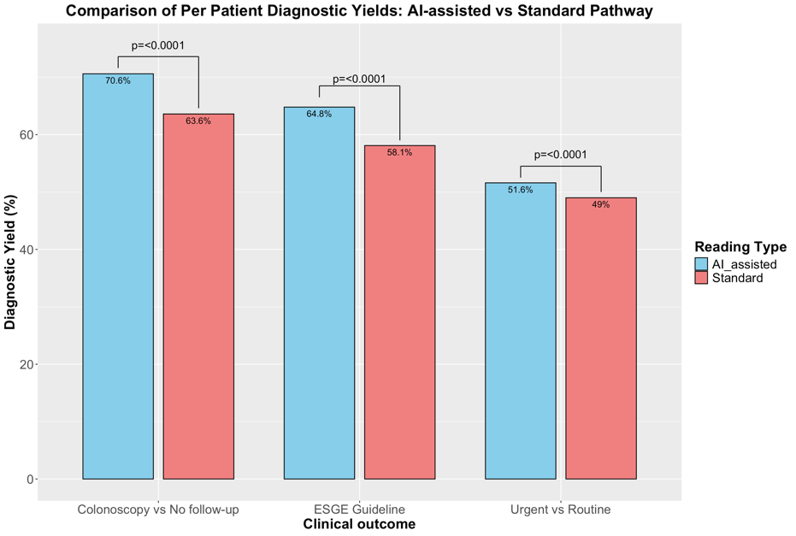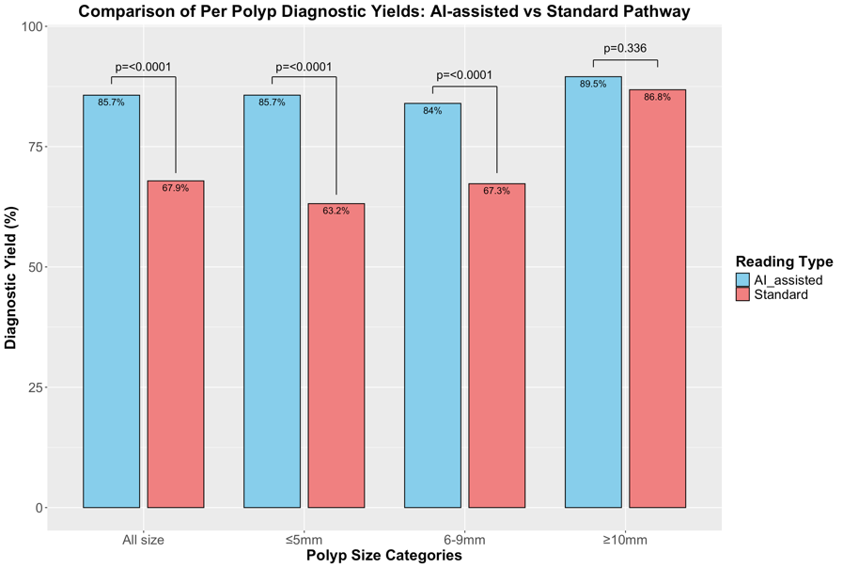
a) Per-Patient Diagnostic yields: Standard vs AI-assisted pathways across clinical outcomes — Colonoscopy vs no Follow-Up, ESGE follow up guideline, and Urgent colonoscopies vs routine colonoscopies. b) Per-Polyp Diagnostic yields: Standard vs AI-assisted pathways across different polyp size categories.
a)
b)

