Primary care-based early detection of Barrett’s oesophagus/neoplasia in patients with reflux using EndoSign®: Real-world insights from the CYTOPRIME 2 study
Peter Holloway, Monica Della Rosa, Ruchika KulKarni, Basirat Afinowi, Rebecca C Fitzgerald, Sarah Killcoyne, Richard H Hardwick, CYTOPRIME 2 care teams, Marcel Gehrung, Danielle L Morris
Introduction
Oesophageal adenocarcinoma (OAC) is the 7th leading cause of cancer-related death in the UK (Cancer Research UK), with Barrett’s oesophagus (BO) as its only known precursor. Gastroesophageal reflux disease (GORD) is a significant risk factor for BO, and while common, current NICE guidelines discourage routine endoscopy referrals due to low diagnostic yield. The EndoSign® capsule sponge test offers a minimally invasive approach to diagnose BO and OAC in patients with GORD, avoiding unnecessary endoscopies. CYTOPRIME2 is the first study aimed at establishing a referral pathway for GORD patients in primary care or community care settings.
Methods
In this prospective study, across 3 English cancer alliances, 17 GP sites were identified and healthcare providers trained to deliver capsule sponge. Suitable patients (≥50 years and prescribed ≥6 months of Proton pump inhibitor) were selected following BEST3 criteria (Fitzgerald et al 2020), using EPR systems (SystmOne/EMIS). A total of 1,965 GORD patients were invited, of which 1,673 were tested over 14 months. Exclusions included recent myocardial infarction, dysphagia, dyspepsia with weight loss, or prior oesophageal treatments. All samples were processed per standard protocols (Landy R. et al, 2023) with slides stained with H&E, Trefoil Factor 3 (TFF3), with p53 biomarker testing performed upon pathologist request.
Results
Of the 1,815 patients tested (including those during nurse training), 1,543 samples (85%) were deemed adequate for pathology review. Based on biomarker findings, 1,195 patients (77.4%) were discharged with safety netting, while 269 patients (16.9%) were referred for follow-up endoscopy, and 74 patients (5.7%) required repeat testing due to inconclusive biomarker results (Figure 1a). Endoscopy outcomes were available for 244 (Figure 1b) of the 269 follow-up patients (90%), revealing 97 new cases of BO (39.8%) and 6 cancers (2.2%), including an OAC staged at T2/3 N1 and an early gastric cancer. Finally, one patient who had an inadequate capsule sponge test was also diagnosed with a T3 OAC after a triage nurse, concerned about symptoms, recommended an urgent endoscopy.
Conclusions
Results from the CYTOPRIME 2 study highlight both the feasibility and benefit of implementing capsule sponge testing in primary care. Cases of BO and OAC were found in targeted patient groups who would otherwise lack diagnostic options, demonstrating that this approach can address care pathway gaps in the NHS. Endoscopy findings suggest enrichment of pathology in this targeted group, compared with recent national studies showing poor yield from routine gastroscopy in unselected GORD patients (Beaton et al 2024). Longer term follow-up data are being collected and will provide further evidence for integrating the capsule sponge test into primary care.
Figure 1: a. Schematic summarizing the primary care capsule sponge referral pathway. b. Bar plot showing outcomes of the endoscopy follow-ups.
a.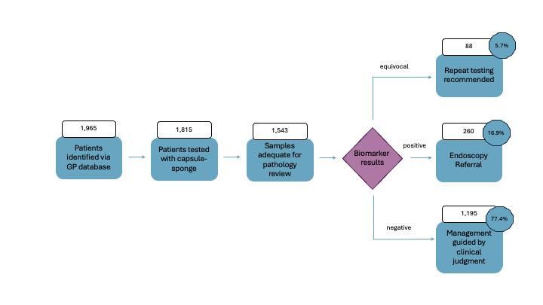
b.